Creating an Object Constructor

* Note: Objects use *PascalCase* naming convention

Syntax:

function ObjectName(param) {

this.param = value

}

Example:

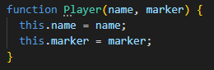

Instantiating a New Object from the Constructor

* Keyword: “new”

Syntax:

const newObject = new ObjectName(args);

Example:



You can also add functions in the Constructor:

